% B30p60a_example_using_expfalltwo_mxl_correction_for_Inna.doc
% Based on analysis performed in B27p129.doc for landings on af488-3591 and cy5-852

% Fit the nonDNA dwell times, expt w/ promoter (3591 and 852 in field)
% uncorrected frequency for AF488-3591 DNA
% (# of binding events)/(total wait time) = binding frequency
NbTb488=1000/4.249792e+005 % = 2.3531E-3 s⁻¹

% uncorrected frequency for background nonDNA locations
NbTbcntrl=129/6.117106e+005 % = 2.1088e-4s⁻¹

% First the nonDNA background fit
% Find all the high events at nonDNA sites

logik=(ciacntrl(:,1)==-3)|(ciacntrl(:,1)==1)|(ciacntrl(:,1)==3);
dwellcntrl=ciacntrl(logik,:); % Dwell times for nonDNA sites
% Fit to biexponential
dw2cntrl=fminsearch(‘expfalltwo_mxl’,[.5 1/5 1/100],[],dwellcntrl(:,5),.5,1e4);
0.1954 0.7489 2.3778E-3 % = [ap rate1 rate2]
% relative amplitude = 1/(1+ap²) = 0.963
[a = 0.9632 1/1.34 1/ 420.56] % Fit to nonDNA, w/ promoter expt
% Compute correction factors for nonDNA distribution based on the above fit
dw2cntrl_cor=expfalltwo_mxl_correction(dw2cntrl,dwellcntrl(:,5),.5,1e4)
CorrectionFactor: 1.4304
Nzero: 184.5162 % 129→184 actual events after correcting
Offset: 3.2000e-010 % for missed events (at short times)

% Fit the af488 dwells with a nonDNA background input as fixed parameters
% Find all the high events at the 488-3591 bp DNA sites

cia488=Intervals.CumulativeIntervalArray;
logik=(cia488(:,1)==-3)|(cia488(:,1)==1)|(cia488(:,1)==3);
dwell488=cia488(logik,:); % Dwell times for AF488-3591

% Fit the dwell with a biexponential plus a nonDNA background
% input as fixed parameters derived from the fit above

dw2bk488=fminsearch('expfalltwo_mxl_with_background',[.5 1/5 1/200],
[],dwell488(:,5),.5,1e4,NbTb488,NbTbcntrl,dw2cntrl)
0.4167 0.3372 0.0161
[a = 0.8521 1/2.9659 1/62.1772]
dw2bk488_cor= expfalltwo_mxl_correction(dw2bk488,dwell488(:,5),.5,1e4)
CorrectionFactor: 1.1539
Nzero: 1.1539e+003 % Not meaningful b/c program uses
Offset: 2.4228e-068 %(Nbtbcy5-NbTbctrl) coefficient

% Plot the 488-3591 data and fit
% B27p129k.fig
% Form the cumulative survival distributions for dwells at the
% af488-3591 bp DNA sites and the nonDNA control sites

cumdwell488=[]; cumdwellcntrl = [];
max(dwellcntrl(:,5)) % =2271 sec (488 is 800 s )
for indx=[0:2272]+0.1
logik=dwell488(:,5)>indx;
cumdwell488=[cumdwell488;indx-.1 sum(logik)];
logik=dwellcntrl(:,5)>indx;
cumdwellcntrl=[cumdwellcntrl;indx-.1 sum(logik)];
end

figure(5);plot(cumdwell488(:,1)+0.5,cumdwell488(:,2)/ 4.249792e+005,'bo');shg
tym=0:2271;
%((OBSERVED 488 freq)-(OBSERVED nonDNA freq))*(correction factor)*(2exp term)
plot(tym, (NbTb488-NbTbcntrl)* 1.1539*( 0.8521*exp(-tym/2.9659)+
0.1479*exp(-tym/62.1772))
+NbTbcntrl*1.4304*(0.9632*exp(-tym/1.34)+.0368*exp(-tym/420.56)),’g’);
% (OBSERVED nonDNA freq) )*(correction factor)*(2exp term)

% Add the nonDNA background data, then the fit
plot(cumdwellcntrl(:,1)+.5,cumdwellcntrl(:,2)/6.117106e+005,'x');shg
plot(tym,NbTbcntrl*1.4304*(.9632*exp(-tym/1.34)+.0368*exp(-tym/420.45)),'k');shg

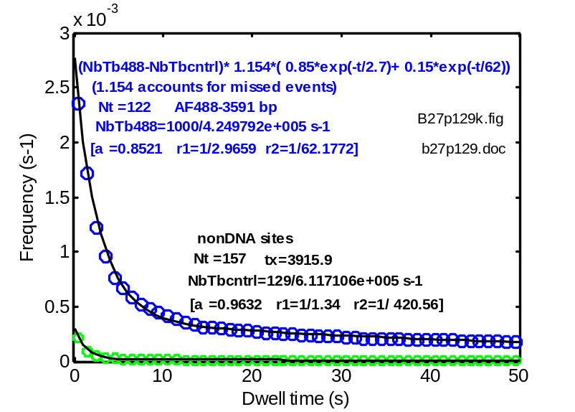
Find above figure on B28p2
expfalltwo_mxl
expfalltwo_mxl_correction
expfalltwo_mxl_with_background
expfalltwo_mxl_correction
% 8/7/2014 Append a bootstrapping example (see B27p129b.doc, specifically B28p2)
%

load P:\matlab12\larry\data\b27p129h.dat -mat
NbTb488=1000/4.249792e+005 % = 2.3531E-3 s-1
NbTbcntrl=129/6.117106e+005 % = 2.1088e-4s-1

tst= bootstrap_expfalltwo_mxl_with_background(dwell488(:,5), [.5 1/5 1/200], dwellcntrl(:,5), [.5 1/5 1/100], .5, 3916, NbTb488, NbTbcntrl, 1000);

% See B28p2 to compare with earlier bootstrap (compares well)

mean((1+tst(:,1).^2).^(-1)) % 0.8540
std((1+tst(:,1).^2).^(-1)) % 0.0156
mean((1+tst(:,4).^2).^(-1)) % 0.9514
std((1+tst(:,4).^2).^(-1)) % 0.0536
mean(tst(:,2)) % 0.3369
std(tst(:,2)) % 0.0204
mean(tst(:,3)) % 0.0153
std(tst(:,3)) %0.0024
mean(tst(:,5)) % 0.7911
std(tst(:,5)) % 0.1106
mean(tst(:,6)) % 0.0065
std(tst(:,6)) % 0.0256

